**Graphical Enigma Simulator**

**Project Guide**

This short guide gives a brief description about this honours project, undertaken by Majed Monem.

Enigma machines were used during and after World War II by the German military. It allowed them to send secret messages to their allies. The main aim of this project was demonstrate the processes of encryption and decryption carried out by an Enigma machine, but only with one rotor. It contains two main features, Encrypt and Decrypt.

Encrypt – allows user to encrypt their plain text into cipher text.

Decrypt – allows user to decrypt their cipher text into plain text.

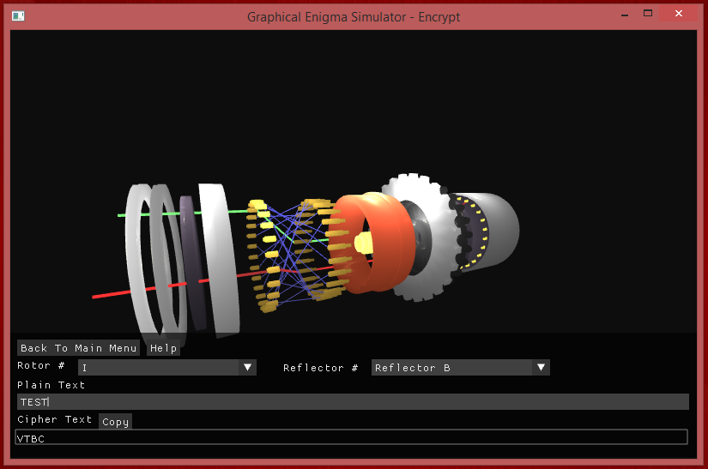

*Figure 1 – Screenshot*

The simulator was developed using C++ alongside OpenGL, for the graphics. ImGui was used to create the user interface. The rotor components were created using Blender, a modelling software. On the end, a reflector can be seen. This is the component which reflects the current back through the rotor to produce the output. The camera angle of the rotor can be changed to look at the rotor from different views.

A User guide and video tutorials are available for further information.